***Offertory Collection:***

Sunday 27th: €520.



Thanks for all your

contributions

and also for the priest’s Harvest collection.

**Bohola/Shraheens Newsletter**

**Stephen O’Mahony PP – 094-9384115/086-8226405 –** [**boholaparish@gmail.com**](mailto:boholaparish@gmail.com) **(email for newsletter)**

<https://www.mayo.ie/news/category/connect/parish-news/bohola-parish-news/>

**27th Sunday in Ordinary Time – 4th October 2020**

###### Masses for the Week

|  |  |  |
| --- | --- | --- |
| **Saturday, October 3rd.** | **8.00pm** | **Private Intention.** |
| **Sunday, October 4th.** | **9.30am**  **11.30am** | **For all the People. (*Live Streamed on Bohola Post Facebook Page).***  **John & Vera Galligan, Ara.** |
| **Wednesday, September 7th.** | **10.00am** | **Private Intention.** |
| **Friday, October 9th.** | **8.00pm** | **Mary Commons, Listrisnane (1st Anniversary).**  **John & Kate McEvey & deceased of McEvey & Jordan families.** |
| ***Mass will be celebrated privately on other weekdays.*** | | |
| **Saturday, October 10th.** | **11.00am**  **8.00pm** | **Bridie Malee, Shanaghy (1st Anniversary) & her husband, John.**  **Jimmy Ruane, Carragowan.** |
| **Sunday, October 11th.** | **9.30am**  **11.30am** | **For all the People. (*Live Streamed on Bohola Post Facebook Page).***  **Private Intention.** |
| ***The 9.30am Sunday Mass will be Live Streamed on the Bohola Post Facebook Page every Sunday.*** | | |

***Recent Death:*** Please pray for the happy repose of the soul of *Maureen Hodder*, Myna Strand, Kilmeena, niece of the late Tom O'Neill, Ardacarra, and cousin of the O'Neills of Ardacarra, who passed away on Wednesday last, 30th September, and whose funeral took place on Friday in Kilmeena. May she rest in peace.

***Baptism:*** On Saturday last, September 26th, we were delighted to welcome *Cillian Nathan Gibbons,* into God’s family. Congratulations to his parents, Nicola and Aidan, his godparents and family and we wish them every blessing for the future

**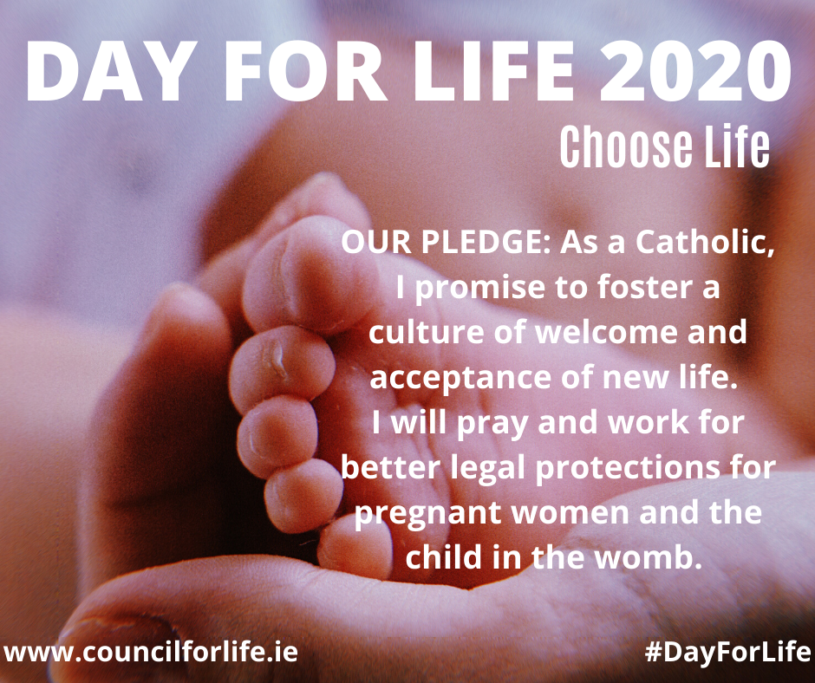*Day for Life*** is celebrated annually by the Catholic Church in Ireland, Scotland, England and Wales. It is a day dedicated to raising awareness of the meaning and value of human life at every stage and in every condition.

This year’s *Day for Life* is celebrated in Ireland today, Sunday 4th October and will focus on the theme: ‘Choose Life’. *“There were 6,666 abortions in the Republic of Ireland in 2019 and over two hundred thousand in Great Britain, including significant numbers from the island of Ireland. We, the Catholic Church, have a message of hope and a story of love; together, we can promote a culture of life”*. The rest of this pastoral message is available on cards left at the entry and exit points of the church. Please take one home.

To learn more about Rachel’s Vineyard, go to [*www.rachelsvineyard.ie*](javascript:disclaimer(%22http://www.rachelsvineyard.ie/%22);).

If you are concerned about an unborn child with a life-limiting condition, go to: [*www.everylifecounts.ie*](javascript:disclaimer(%22http://www.everylifecounts.ie/%22);) or [*www.onedaymore.ie*](javascript:disclaimer(%22http://www.onedaymore.ie/%22);).

Access the Day for Life Resources on [*www.councilforlife.ie*](javascript:disclaimer(%22http://www.councilforlife.ie/%22);).

***World Missions Sunday 18th October 2020:*** The world is in crisis. In many poorer parishes in Africa, Asia, and Latin America, it is overseas missionaries who are on the front line. These women and men already do so much. Walking hand-in-hand with marginalised communities, long before and long after any emergency. Right now, they desperately need your help. Show missionaries you care by supporting their life-giving work. Donate €4.00 by texing the word ‘Mission’ to 50300 (Texts cost €4. World Missions Ireland will receive a minimum of €3.60).Alternatively donate at www.wmi/mission or call Fiona in World Missions Ireland on 01 497 2035.

World Missions Ireland is Pope Francis’ charity for overseas mission. It is part of a global network serving the Church in over 120 countries. Internationally they are known as Missio or the Pontifical Mission Societies and together, with your help, they support overseas missionaries through all challenges, struggles and hardships.

***Priesthood in Achonry Diocese – It is Worth Saying “Yes” to God - Year of Accompaniment:*** A series of six residential weekends will take place in Mullaghmore over the coming months for anyone who may be exploring a call to priesthood. First session runs from Friday evening next, October 9th until lunchtime on Sunday, 11th.

***“There is no need to worry; but if there is anything you need, pray for it, asking God for it with prayer and thanksgiving”*.** You belong to Christ. If the Lord invites you to follow Him as a priest or in the consecrated life, how will you respond? For further information contact our Vocations Director, **Fr Paul Kivlehan, The Presbytery, Ballaghaderreen, Co. Roscommon. Tel.094 - 9860011, Mobile 087 - 3683535, E-mail** [***pkivlehan@achonrydiocese.org***](mailto:pkivlehan@achonrydiocese.org).

***First Confessions*** for the eight members of this year’s First Communion class was celebrated on Tuesday evening last, approximately six months behind schedule, yet another consequence of Covid-19. Well done to our new little angels and thanks to their families, to Mrs Mulligan in the school and to all who helped them prepare and celebrate this important milestone in their lives. Thanks also to Mrs. Mulroy for producing the lovely booklet for the ceremony. We look forward to First Communion on October 17th and we trust the haloes will still be shining!

***‘Zoom Family Rosary’*:** Come and join us to pray the Family Rosary on Zoom every Saturday evening at 6:00pm. The Family Rosary lasts for 20 minutes. It starts with a short two-minute video followed by the Rosary, which is led by parents and prayed by children from participating families from different parts of the world. To join the ‘Zoom Family Rosary’, follow the link *http://bit.ly/ZoomFamilyRosary* to register. Once registered, you will receive a return email with your own personal link.

***Rosary Crusade:*** Archbishop Eamonn Martin is asking families to pray the Rosary together for the month of October in what is called the *Family Rosary Crusade***.**

On Saturday, October 10th the *Hail Holy Queen Conference*will beon Radio Maria Ireland, beginning with the Rosary from 12.30pm. Guest speakers include Dana, Marino Restrepo, Fr Damian Polly, Fr Ruairi O'Domhnaill, Fr Marius O'Reilly and more.

On Sunday, October 11th, the*Rosary on the Coast for Life & Faith in Ireland*will take place. This year we will again join in with many other countries from around the world. We will gather on our coasts, at our grottos, our churches, our river banks, our homes, or wherever we can....... to pray the Rosary safely together, at 2.30pm. Please do remember to observe Covid-19 guidelines. See [*www.coastalrosaryireland.ie*](http://www.coastalrosaryireland.ie/) to see locations near you or to register a location.

***Galilee Spirituality Centre: Autumn Update:*** Much of our activity will be online in the coming weeks and months, and our activities in the house and garden will continue to be influenced by government guidance on the COVID virus. Do keep an eye on the website which will have all the updates about further events or any changes [*www.galilee.ie*](http://www.galilee.ie/). These are changing times and we are doing our best to adapt to the developing needs.

*Prayer ministry:* As always, you are welcome to ring Galilee to request prayer 071-9664101. We invite everyone to join us in prayer, wherever you are, at 6.00pm Tuesday, Wednesday and Thursday.

*That your Love may Overflow (Phil 1): Exploring Acts and the Letters of St Paul:* In these four short videos our presenters give an introduction to these scriptures which will help us make sense of the world of the early Church and how these readings can speak to us today. Available at <https://www.galilee.ie/online-programmes/> Free of charge. *Paul: Considering the man and his message - Dympna Mallon. Philippians: Paul's Joyful Letter - Dr Jessie Rogers. The Acts of the Apostles: a community of faith - Philomena Clare. What Acts tells us about the women of the early Church - Marian Mortell.*

***Bohola Post:*** The deadline for submission of material to the 2020 edition of the Bohola Post is Friday, October 30th. Get your articles and/or pictures in as soon as possible by emailing [*boholapost@gmail.com*](mailto:boholapost@gmail.com). We can only take submissions this year by email due to the Covid-19 situation. More help is always needed so if you can assist in any way with the "Post" please contact us by email. Any help will be welcome.

***Moy Davitts 50/50:*** Congratulations to Teresa Gril, Bohola, on winning €339 in the Moy Davitts 50/50 draw. A huge ‘thank you’ to everyone who supported last week's draw, it is greatly appreciated. Tickets are available in the usual retail outlets and by clicking [*https://smartlotto.ie/Bohola-moy-davitts*](https://l.facebook.com/l.php?u=https%3A%2F%2Fsmartlotto.ie%2FBohola-moy-davitts%3Ffbclid%3DIwAR2-SMSQVJnLPM1gbMk8VYcVq5QSNWsE5b18UD-SHwPhuifGrX08SNDlJc8&h=AT0MiLZlj4q4DBPOl03vVXSokuVERXZawyK8tGPOdkMD6iUtbbGAIDrP1wUMXoHHwBpf8OCfEYLll7lUaWyYzni7elqLyyDX1hxrkiRT4iLddt75pWrUPCYemDN43SvOspaI&__tn__=-UK-R&c%5b0%5d=AT1bnP92vRmesJAH-zh16Oyc956taFyWxM0_3VLfj4QSf9SmpZw5cpQ61Vc5tvJdChYPj7SPty0LDMmT-1CuL0y1Dj6Ia-SpXR1Lif8cNpBMb3zmcNd83NlOLtCy4LEd6sxibGw9D72uG7DGqfgmtrvFR5ZcIPXTwnc_aJIQcIYHHlU6GWM4y_sHX7uH). Best of luck everyone and thanks again!

***Mayo Roscommon Hospice:*** Due to the current government guidelines and restrictions around Covid-19, it is not possible to hold our annual Hospice coffee morning. However, if you wish to make a donation you may do so on *www.*[*hospice.ie*](http://hospice.ie/). Alternatively, if you prefer, you can drop a donation into Clarke's shop in an envelope . This will be open until next Wednesday, 30th September. All donations big or small will be very welcome. Thanks again to all for your support.

***St Vincent de Paul Collection:*** The local branch of St Vincent de Paul holds its annual collection at this time of year. In the past it was taken up at the church door on a given weekend at each Mass. Because of Covid-19 regulations, that method of collection is not possible this year. Instead, envelopes are available in the church porch and at exit doors. If you wish to make a contribution, please put it in one of these envelopes and return it with the offertory donations over the next few weeks. It is likely that there will be a greater demand on the services of the St Vincent de Paul this year due to loss of employment or drop in income among some families, another consequence of Covid-19. Please be as generous as possible.

***Anam Cara Galway,*** the organisation that supports bereaved parents, is holding its monthly *Parent Evening* for bereaved parents on Wednesday, **7th October** at 7:20pm in the Clayton Hotel, Galway. This event is free and open to all bereaved parents regardless of the age your child died, the circumstances of their death, or whether their death was recent or not. For more information, see [*anamcara.ie*](http://anamcara.ie/) or call our Information Line on 01 4045378.

***Autumn 2020 Night Classes Westport College of Further Education:*** Classes commence on the week of October 5th for both Certified and Hobby courses. Detailed information on [*www.westportcfe.ie*](http://www.westportcfe.ie/) in the night class section or please call 098-50800.

***COVID-19 Support Line for Older People:***ALONE manage a national support line and additional supports for older people who have concerns or are facing difficulties relating to the outbreak of COVID-19 (Coronavirus). Professional staff are available to answer queries and give advice and reassurance where necessary. The support line is open seven days a week, 8am to 8pm. The contact number is ***0818-222024***.

***Lazy people fact # 354630982710***

***You were too lazy to read that number!***