Welcome to Mayo County Council's Consultation Portal Using this site you can participate in public consultations and submit applications for funding schemes.

Register for an account to make an application. The registration process is a one-time process, and your account can be used for all of the Council's online public consultations. You will be able to record your submissions across multiple consultations/applications and save the progress of partially completed submissions to complete later.
Other than required by law, your personal information such as contact details collected as part of the consultation process is protected by data protection. They will remain confidential and will not be published or shared with third parties.

- Homepage

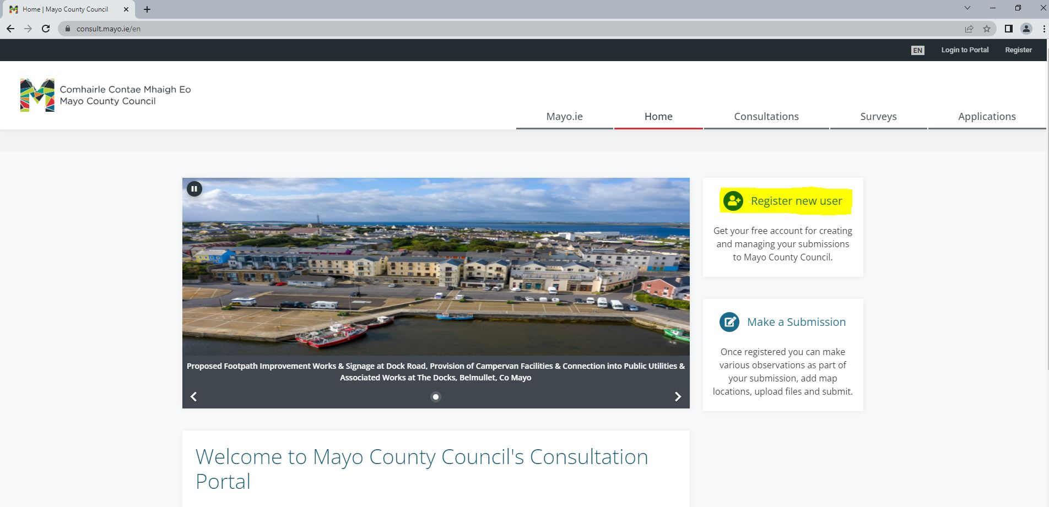

- Register as an Individual

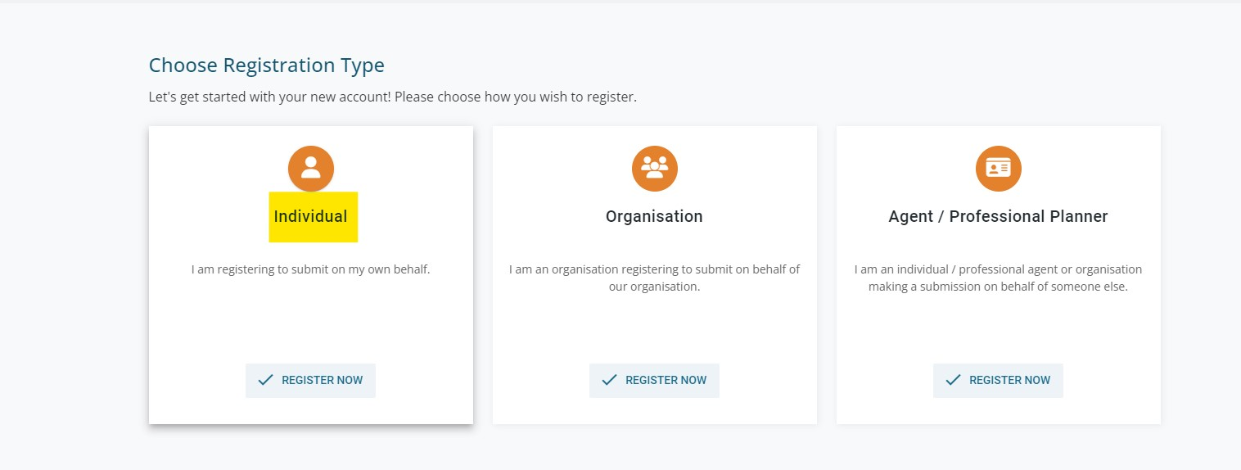
- Registration Page
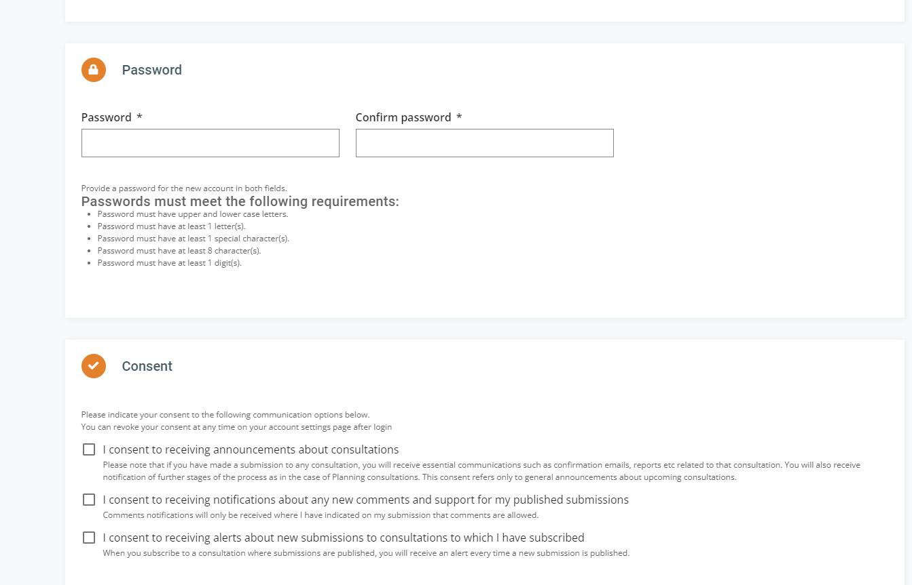

- Create Account
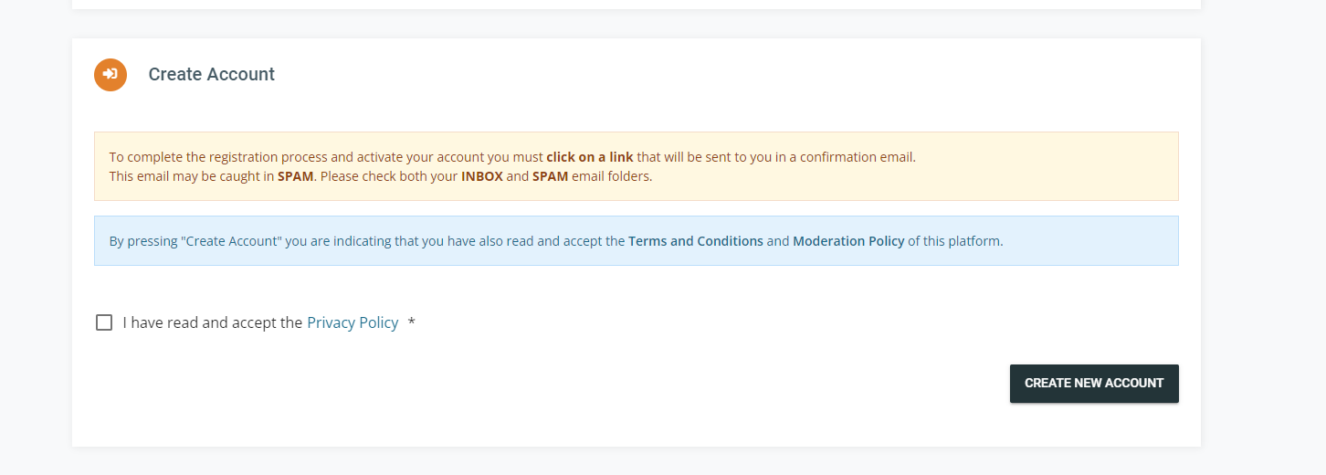
An email will be sent to the email address you provided, and you must click on this link to activate your account.
- Two Factor Authentication
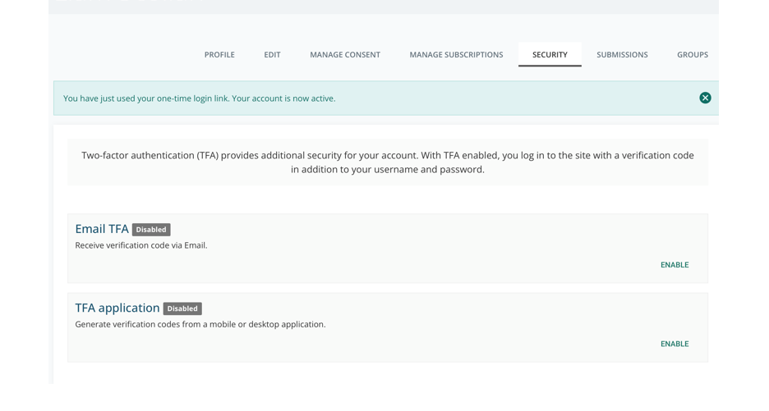
You must enable 2 factor authentication. There are 2 options:
- Receive an email each time you log in with a verification code. It will use the email address from when you created the account (Recommended)
- Download an app to your phone and verification will be through the app.

- Applications

- 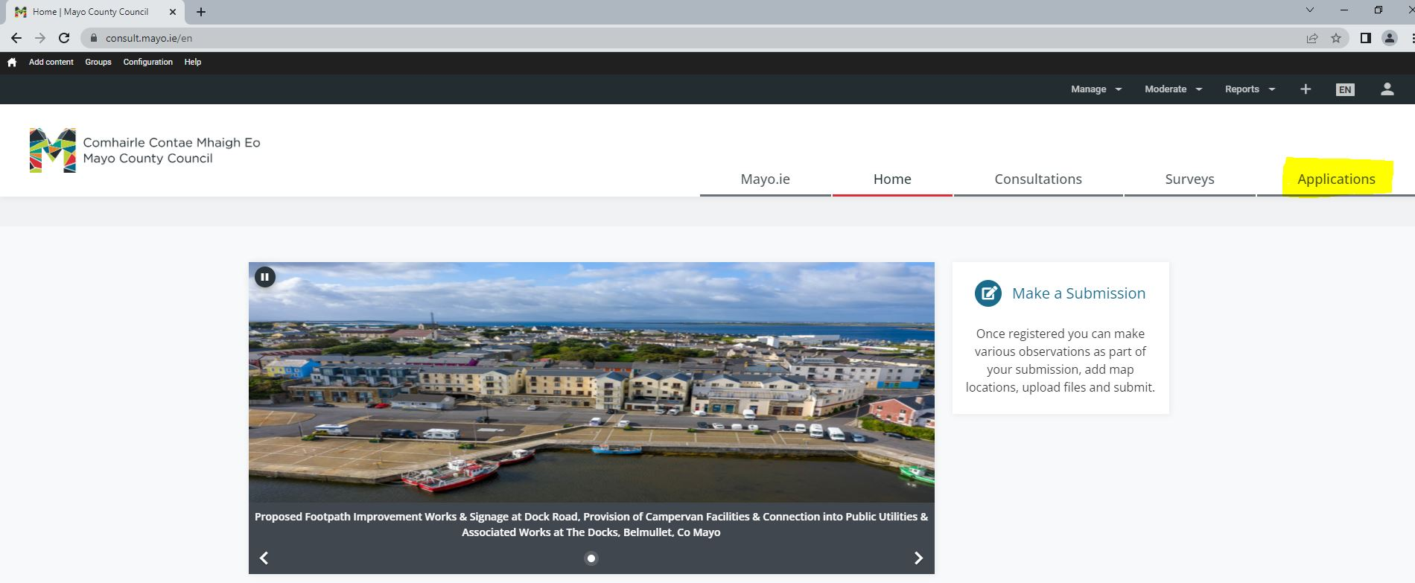
Once you are logged in and have created your account, go to Applications and select the form you wish to submit.

