IRISH TOURIST ASSOCIATION SURVEY – CO MAYO
1942-1945

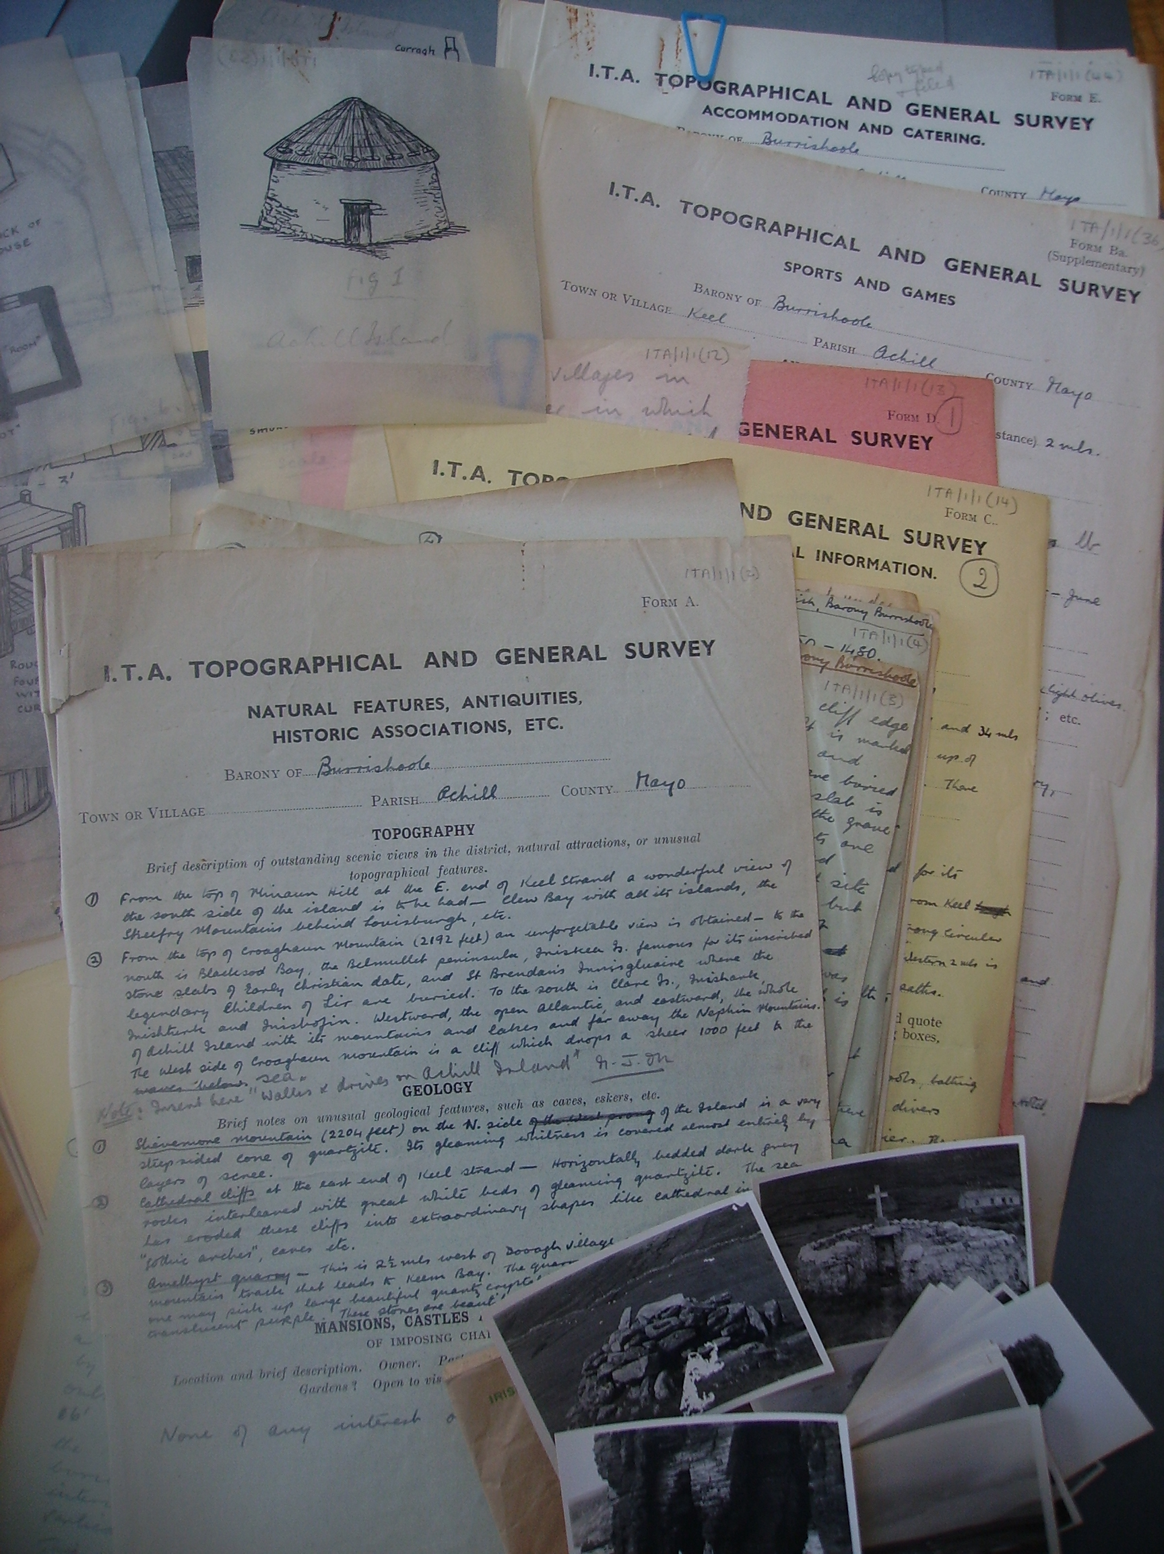

A DESCRIPTIVE LIST

compiled for

MAYO COUNTY LIBRARY

by Brigid Clesham (Archivist) - May 2008

