Film Mayo Creative Ireland Award 2020
Application Form

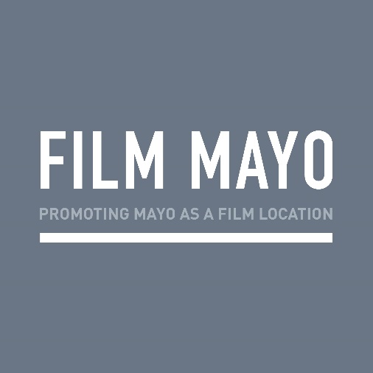

- Contact Details:
Name:

Address:

Telephone:

Email:

2. In what capacity are you applying for this award ?
(E.g Screenwriter, Director, Producer, Technical crew, film artist etc)

3. Please confirm by ticking the appropriate box/boxes that you were either born in Mayo and based in Ireland or are currently living in Mayo
Born in Mayo and based in Ireland ☐ Currently living in Mayo ☐

4. Filmmakers Approach to Award:
Please outline your approach to the award and please include concepts/scripts/ideas you will be working on during this time. Max 200 words

5. Timescale:
Please outline your timescale which must take place between December 2020 and July 2021. (minimum of 20 days) Max 200 words

6. Budget:
Please outline in the application how you envisage using the budget of €8,000. The outline must include filmmakers fee and all other costs.

7. Mentors:
Please outline how you would envisage the best use of your time with your suggested mentors and what you would wish to achieve from these mentoring sessions. Please provide the name and area that your suggested mentor works in and outline if you have an established relationship with the mentor or if you need assistance in engaging mentors Max 200 words

8. Áras Inis Gluaire Facilities:
Please outline how you would envisage the best use of Áras Inis Gluaire facilities during the Award. Max 200 words

9. Community Engagement:
Please outline in your proposal how you would engage with community during the Award. Max 200 words

10. Award Outcome:
Please outline projected outcomes from the Award. Max 200 words

11. Tyrone Guthrie Residency:
Please outline what you would work on during your time in the Tyrone Guthrie Centre and how this would benefit your current practice? Max 200 words

Checklist:
Please indicate that the following material is included with your application by ticking the items below:
- Completed application form
- Filmmakers C.V. no more than two pages, outlying screen credits
- Other supporting material. e.g. scripts, links etc.

Email submissions only to: E: filmmayo@mayococo.ie; with Film Mayo Creative Ireland Award 2020 in the subject box.

For further information:
Film Mayo, E: filmmayo@mayococo.ie T: 094 906 4666
Selection: Mayo County Council retains the right not to commission if a selection is not recommended by the judging panel.
Deadline for submissions: 5pm, Monday 16th November, 2020.

