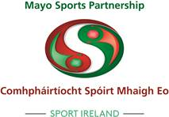

Name of applicant Club:_______________________________

Club Volunteer Training/Development Grant 2020

PLEASE READ CAREFULLY:
The Mayo Sports Partnership Club Development Programme provides limited assistance to sport and recreation clubs/organisations within County Mayo for Club Volunteer Training/Development.

This scheme reflects and will contribute to, the strategies of Sport Ireland,
Coaching Ireland and Mayo Sports Partnerships Strategic Plan 2017 – 2021.

This Grant Scheme aims to increase participation and improve the management and administration
of clubs and in particular, to develop youth structures in clubs/organisations, thereby providing sport
and physical activity opportunities.

Priority will be given to minority sports who do not have development officer support in the county.
Priority will also be given to training /education initiatives which target increased participation by women / girls, ethnic minorities, young people, disadvantaged.

Guidelines for Club Volunteer Training/Development Grant
Applicants will be assessed and allocation of grants determined having regard for the criteria
below :
NB: ALL PROJECTS SHOULD BE IN LINE WITH COVID19 PROTOCOLS

Eligible Courses (may include): Ineligible Courses (will include):

Sports specific Coach Education Courses outside Ireland
(e.g Athletics, Basketball, Badminton,
Water Sports etc)

Sports Leadership Sports Education Seminars, Sport related courses delivered by bodies not
Upskilling of volunteers etc recognised by Sport Ireland, Coaching Ireland
or by the National Governing Bodies of Sport (NGB’s) if one exists.
Disability Inclusion Training, Autism in Sport etc
Safeguarding courses through the Sports
Partnership which are subsidised
Accredited courses by Coaching Ireland
or National Governing Body of Sport Generic sports courses delivered by a non-recognised agency

Clubs with Youth Structure in place must Day to day running costs (eg. insurance,transport).
Have a Safeguarding Policy, Garda Vetting
Childrens Officer in place Applicants from individuals (applications must
be made by the club/organisation).
Virtual Sports Volunteer Training / Education
in line with COVID19 protocols

Applications from clubs/organisations within Courses not directly related to applicant
Co. Mayo club/organisation (eg. team building).

PLEASE READ CAREFULLY:
NOTES:

- As there are a limited number of grants emphasis will be placed on the quality of
the grant application.

All grants for training courses etc will be paid retrospectively on submission of invoice
received and report by the grant aided club.

- Organisations must have a Constitution / Rules or in the case of Companies
Memorandum & Articles of Association. Please attach copy to application.

Evidence of own bank account must be submitted

- All applicants must be registered or agree to be registered on the database of
the Public Participation Network. To register with the network go to this link http://www.mayoppn.net/Join.html

Applicants should sign up to the CARA Sports Inclusion Disability Charter see below link for more
www.caracentre.ie/sport-inclusion-disability-charter

- On receipt of applications a club/organisation may be requested to make
minor amendments to their application following consultation with the
Sports Co-ordinator.

- Applicants should note that successful clubs/organisations must comply with
any reasonable request regarding publicity from Mayo Sports Partnership.

- Any club/organisation funded under this scheme must submit an end of project /course
report to the Mayo Sports Partnership.

Priority will be given to minority sports who do not have development officer support in the county. Priority will also be given to training /education initiatives which target increased participation by women / girls, ethnic minorities, young people, disadvantaged.

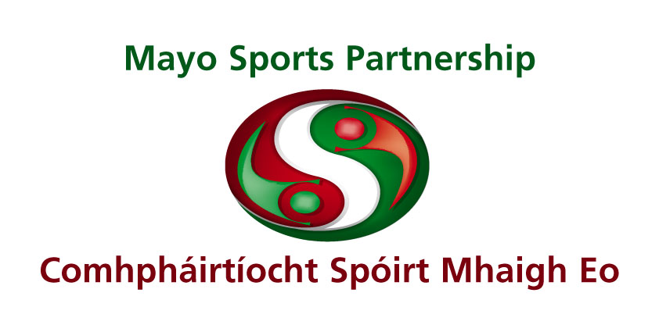

CLUB VOLUNTEER TRAINING GRANT - APPLICATION FORM

Section 1: Club/Organisation Profile

1. Applicant Details:
Name of Club/Organisation: __________________________________________
Chairperson: __________________________________________
Treasurer: __________________________________________
Secretary: __________________________________________
Name of club’s bank account: __________________________________________

For Correspondence
Applicant Name: _______________________ Position in club: _______________________

Address: _____________________________________________________________________

Tel No: ______________________ Email: __________________________________________

2. (i) Is your club/organisation affiliated to a National Governing Body? Yes: ___ No: ___

(ii) If yes, please state name of NGB. __________________________________

3. Club/Organisation membership details: (please give numbers)

Age Group | Male | Female
Under 12 years
13 - 18 years
19 – 45 yrs (Senior)
46 yrs plus (Veteran)

Total

4. Does your club charge a membership fee? Yes _______ No _______
If yes, please specify: ______________________

5. Does your club charge its members for coaching sessions? Yes _______ No _______
If yes, how much per session? ______________________

Section 2: About your Club
6. Please describe the purpose of your club/organisation and specify the sports/physical activities you provide for your members: ________________________________________________________________________________________________________________________________________________________________________________________________________________________________________________
________________________________________________________________________________

7. (i) Does your club/organisation partake in inter-club competitions (leagues/cups etc)?
Yes _______ No _______

(ii) If yes, please specify: ________________________________________________________________________________________________________________________________________________________________________________________________________________________________________________
________________________________________________________________________________

8. Please specify qualified coaches in your club:

Name of coach | Qualification held | Awarding Body

9. Safeguarding
(i) Does your club have a Safeguarding policy? (If yes, please attach a copy)
Yes _______ No _______

(ii) Has you club/organisation held/attended a Safeguarding Level 1 Course?
Yes _______ No _______

If yes, how may members have been certified? _____________
Name of certifying body: _______________________________________________

If no, would you be prepared to attend such a course?
Yes _______ No _______

10. Does you club offer opportunities for participation for people with disabilities?
Yes _______ No _______

If yes, please specify:
________________________________________________________________________________________________________________________________________________________________

Would your club be prepared to attend a workshop on Disability Inclusion Training? Yes _______ No _______

Please sign up to the CARA Sports Inclusion Disability Charter see below link for more
www.caracentre.ie/sport-inclusion-disability-charter

Section 3: Club Training/Development
Assistance is available to clubs/organisations in respect of participation in approved Training/Coach Education/Workshops promoting sport for young people.

Description of identified Training/Education Course

11. Name of Participant(s) for Training/Coach Education Course:
- ________________________________________________
- ________________________________________________
- ________________________________________________
- ________________________________________________

12. Course details:
(i) Course Title: ____________________________________________________________
(ii) Organising/Accreditation body: ______________________________________________
(iii) Level of course (ex. Introductory, Level 1 etc): __________________________________
(iv) Venue: _______________________________________________________________
(v) Date and Duration: _______________________________________________________

13. Briefly outline the objectives for doing the course and how it will benefit your junior club development.
________________________________________________________________________
________________________________________________________________________
________________________________________________________________________

14. Estimated cost of Training/Coach Education Course: € _______
The costs are expected to be met as follows:
- From personal funds € _______
- From club funds € _______
- From Mayo Sports Partnership
Training Development Grant Scheme € _______

15. Please detail how funding from the Mayo Sports Partnership will be spent:

Element | Amount €
TOTAL | €

SIGNED: _________________________ DATE: ______________
(on behalf of club/organisation)

Completed application forms should be returned to:
Mayo Sports Partnership,
Community and Integrated Development, Mayo County Council, Castlebar, Co. Mayo
Before 5pm Friday 23rd October 2020

Tel: 094 – 9064360, Email: msp@mayococo.ie , www.mayo.ie/sports-partnership

MSP Club Training Grant
CHECK LIST

Application Form (Fully completed and signed)

In the case of Clubs and Voluntary Groups/Organisations
Submit:
-copy of Constitution/Club Rules & Structure

Detailed costing of Training Programme

Any Further Information

