MASS INTENTIONS

(Saturday 12th March to Sunday 20th March 2022)

MYNA CHURCH

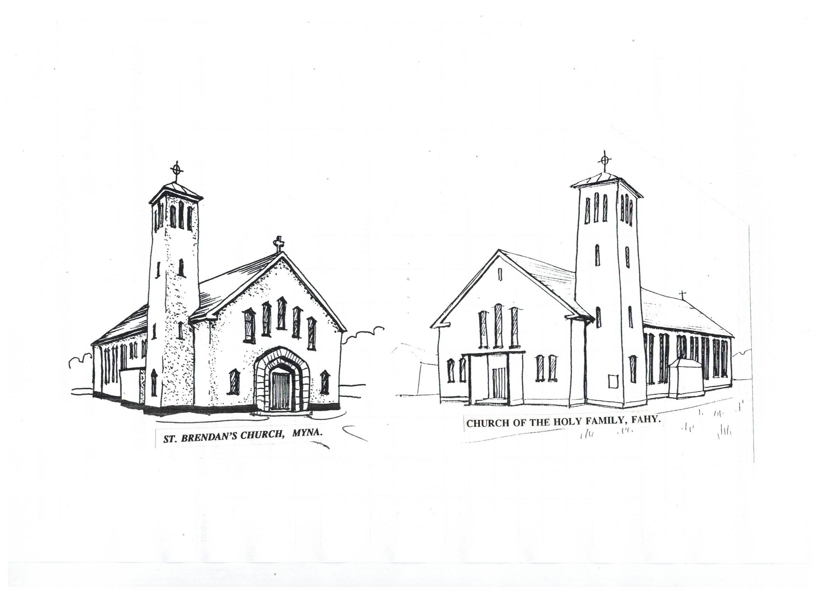
SUN 11.30am. Michael Cafferty, (A) Carrowholly.

Peter and Bridget Burke and deceased family members,

Drunnagh.

Alan Browne (A) and his father Jim and deceased family

members, Drimgarive.

John Gill (A) and deceased family members, Kilmeena

Hill.

TUE 9.30am Mass for the People of the Parish.

WED No Mass.

THU 11.30am St. Patrick’s Day – Michael Joe Mullarkey and deceased

family members, Gortawarla

FRI 8.00pm. Mass.

SUN 11.30am. Paddy and Mena Burke, Cornaool and Drunnagh and

deceased family members.

Michael Joe and Mary Moran and deceased family

members, Rossakeeran.

FAHY Church

SAT 7.00pm Mike (A) and Barbara Duggan and son Martin and

deceased family members, Derryribbeen.

Mary Walsh (A), Dooleague, Islandeady.

MON 8.00pm. Mass.

WED 7.00pm St. Patrick’s Day - Mass.

SAT 7.00pm Mass.

*****

CHURCH SYNOD 2021-2023:

Pope Francis has called the whole church to a synodal way. The aim of this Synod is to foster and develop the Church’s synodal nature through sharing openly and honestly our lived experience of Church life and mission. All will be invited to a meeting where they will be able to pray, reflect and discuss a number of questions and where everybody’s views will be heard. Feedback will be recorded and submitted to the diocesan synod team. Tis process will lead up to the Synod in Rome in October 2023.

A leaflet explaining the whole process is available on the table in the church porch.

. KILMEENA – FAHY PARISH

NEWSLETTER

Sunday 13th March 2022 Second Sunday of Lent.

The faith St. Patrick preached was positive and life giving. It was also a faith that inspired sacrifice and service of others. Genuine faith is always like that. It expands the possibilities of human love and courage.

Fr. Jim Walsh, P.P. (098-41270)

PARISH NEWS:
THE SEASON OF LENT:

During Lent we prepare for Easter by conversion of heart. That means turning away from all that is evil in our lives and turning back to God. So, for the forty days of Lent we use Penance (e.g. fasting or giving up something we enjoy), Prayer (e.g. daily Mass, weekly Holy Hour, Stations of the Cross, Rosary, visits to the Blessed Sacrament, Bible reading and meditation) and Almsgiving (e.g. helping the poor and needy in the Third World by contributing to Trócaire.)

Trócaire Family Fast Boxes are available in the church porch.

****
FEASTS OF THE WEEK:
Thursday is the feast of St. Patrick and is a holyday of obligation. Mass in Fahy church will be at 7.00pm on Wednesday and in Myna church at 11.30am on Thursday.

Friday: St. Cyril of Jerusalem, bishop and doctor of the church (315-386). He was bishop of Jerusalem and was exiled because of his opposition to the Arian heresy.

Saturday: St. Joseph, Husband of the Blessed Virgin Mary. He is seen as the natural protector of Christian families and of those whose daily bread is uncertain. His holiness is the ordinary man’s holiness.

*****
TRÓCAIRE LENTEN CAMPAIGN AND UKRAINE:
The crisis in Ukraine is a devastating humanitarian disaster which people in Ireland are responding to with deep compassion. The most effective way to provide support to the people of Ukraine is to donate money to humanitarian agencies that are working on the ground in Ukraine and Poland, like Trócaire. You can express your kindness and compassion to people fleeing conflict everywhere by making a donation to Trócaire’s Ukraine appeal in addition to your donation to Trócaire’s Lenten appeal.

TRÓCAIRE and LENT:

As Lent begins, we call to mind those in our world who are most in need of our help. We remember in particular the one in six people who today will go to bed hungry. In a spirit of repentance let us resolve to keep these people close to us during the holy season of Lent.

******
ST. PATRICK’S DAY EMIGRANT COLLECTION:
Emigrants are remembered in a special way today. The Offertory Collection at all Masses on St. Patrick’s Day in Ireland will be in aid of Irish emigrants. Many Irish men and women who emigrated to England are now old and living in poor circumstances. In difficult times they helped their people at home. Let us be generous now that they need our help.
LÁ FHÉILE PHÁDRAIG:
Best wishes to all parishioners and all who are on holidays in our parish for a very happy St. Patrick’s Day.

*****
DATES FOR FIRST CONFESSION FOR FIRST HOLY COMMUNION:

First Confessions for Fahy school children will be heard in Fahy Church at 10.30am on Tuesday, 15th March; for Carrowholly school in Myna Church at 10.00am on Wednesday, 16th March; for Myna school in Myna church at 11.00am on Tuesday, 16th March.

****
KILMEENA GAA All Ireland Champions Celebration Dinner Dance will be held in the Castlecourt Hotel on Sunday, March 20th at 6.30pm Tickets €50.00. Over 18’s only. Music by Wavelength. Contact Darren Madden – 0872888744 for tickets.
25 CARD DRIVE in Kilmeena GAA club house every Monday night at 8.30pm. All are welcome.
***
SAINT PATRICK’S DAY parade in Newport starts at 2.00pm from campus on the Westport Road, anyone wishing to join in the parade to be there no later than 1.30pm, come along and join in what hopefully is going to be a great day to reconnect with old and new friends.

****
KILMEENA COMMUNITY ALERT NOTES:
The AGM of Kilmeena Community Alert took place on the 10th March 22 and the following officers were elected: Chairperson - Michael Mulchrone; Vice Chairperson - Noleen O'Grady; Treasurer - Chris Flynn; Assistant Treasurer - Noreen Johnstone; Secretary - Declan Moran; PRO - Ollie Collins
Kilmeena Community Alert Church Gate Collection will take place on Sunday, 20th April. Please be generous.
The Guards are asking people to be extra vigilant with their oil tanks and to make them as secure as possible as theft of oil may occur due to the ongoing hikes in the price of oil.
Anyone with farm machinery or personal equipment can they please mark their items with their eircode for identifying purposes in the event if items are stolen. They can then be returned to the rightful owners. The Guards have a specialised heating equipment to mark a unique number on any farm machinery or personal equipment and a day will be organised in the future for anyone wanting to have their equipment marked by them. More to follow on this.

