Insert organisation logo here

Annual Fire Safety Register
__________(Year)

Name of Premises: | ____________________________________________________________  ____________________________________________________________
Address: | ____________________________________________________________  ____________________________________________________________  ____________________________________________________________
Eircode: | ____________________________________________________________

Owner/Hirer/Lessee: | ____________________________________________________________
Contact No: | ____________________________________________________________
Business type: | ____________________________________________________________

Fire Safety Manager: | ____________________________________________________________
Contact No: | ____________________________________________________________
Deputy Fire Safety Manager: | ____________________________________________________________
Contact No: | ____________________________________________________________

Assembly point locations: | ____________________________________________________________  ____________________________________________________________  ____________________________________________________________  ____________________________________________________________  ____________________________________________________________  ____________________________________________________________

Contents

1. Introduction 4
2. Fire duties assigned to a particular staff member 5
2.1 Fire safety duties assigned to a particular staff member 5
2.2 Guidance for completion of the Fire Safety Register 7
3. Staff Training 8
3.1 Training outline 8
3.2 Training Record Form 9
4. Fire evacuation drills 10
4.1 Drill outline 10
4.2 Fire and Evacuation Record Form 11
5. Fire Action Notices 12
6. Inventory of fire safety equipment 16
6.1 Fire detection and alarm system 16
6.2 Emergency Lighting 17
6.3 Firefighting equipment 18
6.4 Fire resisting doorsets 19
6.5 Fire Hydrants 20
6.6 Dry / Wet Risers 21
7. Fire Safety Checks 22
8. Scheduled checks logbook 23
8.1 Annual checks 23
8.2 Quarterly checks 24
8.3 Monthly Checks 25
8.4 Weekly Checks 26
8.5 Issue record 27
8.6 Scheduled checks guidance 28

Introduction
Section 18(2) of the Fire Services Acts, 1981 and 2003 generally applies to all premises other than a dwelling house occupied as a single private dwelling. Section 18(2) states:
“It shall be the duty of every person having control over premises to which this section applies to –
- take all reasonable measures to guard against the outbreak of fire on such premises,
- provide reasonable fire safety measures for such premises and prepare and provide appropriate fire safety procedures for ensuring the safety of persons on such premises,
- ensure that the fire safety measures and procedures referred to in paragraph (b) are applied at all times, and
- ensure, as far as is reasonably practicable, the safety of persons on the premises in the event of an outbreak of fire whether such outbreak has occurred or not.”

The Department of Housing, Local Government and Heritage has published guidance to assist persons in control of particular types of premises in discharging their statutory responsibilities under the Fire Services Act. The publications include the following:-
- Code of Practice for the Management of Fire Safety in Places of Assembly
- Guide to Fire Precautions in Existing Hotels, Guesthouses and Similar Premises
- Fire Safety in Guest Accommodation
- Fire Safety in Hostels
- Fire Safety in Nursing Homes
- Fire Safety in Preschools

All documents available to download from https://www.housing.gov.ie/Publications

Compliance with responsibilities under the Fire Services Act requires that –
- The premises must be suitable for its intended use and certain essential fire safety features appropriate to the use of the premises must be provided, and
- A proactive fire safety management policy must be in place to minimize the risk of a fire occurring and ensure the safety of persons on the premises in an emergency.

The keeping of fire safety records is a key piece of evidence that an Owner / Operator is discharging their statutory duties as outlined in Section 18(2) of the Fire Services Acts 1981 and 2003 and is an important element of the fire safety management of a premises. This Fire Safety Register Logbook has been produced to assist in the keeping of records for specific items. It will also be necessary to keep records and certificates for other items such as furnishings, bedding, electrical installations, and gas installations as appropriate to the premises.

It should be noted that this is a guidance document only - further information may be required depending on the active & passive fire protection in the building, materials stored in the building, and profile of building user.

Fire safety duties

Fire safety duties assigned to a particular staff member
Name: | ____________________________________________________________
Position: | ____________________________________________________________  ____________________________________________________________
Fire Safety Duties: | ____________________________________________________________  ____________________________________________________________  ____________________________________________________________  ____________________________________________________________

Name: | ____________________________________________________________
Position: | ____________________________________________________________  ____________________________________________________________
Fire Safety Duties: | ____________________________________________________________  ____________________________________________________________  ____________________________________________________________  ____________________________________________________________  ____________________________________________________________

Name: | ____________________________________________________________
Position: | ____________________________________________________________  ____________________________________________________________
Fire Safety Duties: | ____________________________________________________________  ____________________________________________________________  ____________________________________________________________  ____________________________________________________________  ____________________________________________________________

Name: | ____________________________________________________________
Position: | ____________________________________________________________  ____________________________________________________________
Fire Safety Duties: | ____________________________________________________________  ____________________________________________________________  ____________________________________________________________  ____________________________________________________________  ____________________________________________________________

Name: | ____________________________________________________________
Position: | ____________________________________________________________  ____________________________________________________________
Fire Safety Duties: | ____________________________________________________________  ____________________________________________________________  ____________________________________________________________  ____________________________________________________________  ____________________________________________________________

Name: | ____________________________________________________________
Position: | ____________________________________________________________  ____________________________________________________________
Fire Safety Duties: | ____________________________________________________________  ____________________________________________________________  ____________________________________________________________  ____________________________________________________________  ____________________________________________________________

Name: | ____________________________________________________________
Position: | ____________________________________________________________  ____________________________________________________________
Fire Safety Duties: | ____________________________________________________________  ____________________________________________________________  ____________________________________________________________  ____________________________________________________________  ____________________________________________________________

Name: | ____________________________________________________________
Position: | ____________________________________________________________  ____________________________________________________________
Fire Safety Duties: | ____________________________________________________________  ____________________________________________________________  ____________________________________________________________  ____________________________________________________________  ____________________________________________________________

Guidance for completion of the Fire Safety Register
The register should be kept up-to-date and should be available for inspection by an Authorised Fire Officer of Mayo County Council at all times.
This register contains blank templates for each of the necessary check to be carried out daily, weekly, monthly, quarterly and annually. These templates should be printed/photocopied as many times as necessary for continued record keeping throughout the life of the register. It is recommended that a new register is opened every five years maximum.
Managers should take careful note of the intervals at which drills, tests or inventory/location checks are to be carried out. These are summarised in the table below:
 | Fire evacuation drills | Means of escape | Fire doors | Fire detection and alarm system | Emergency lighting system | Fire extinguishers and fire blankets | Hose reels and Fire hydrants*
Daily |  | ✓ | ✓ | ✓
Weekly |  |  |  | ✓ | ✓
Monthly |  |  |  |  |  | ✓ | ✓
3 monthly |  |  |  | ✓ | ✓
6 monthly |  |  | ✓
Annually | ✓ |  |  | ✓ | ✓ | ✓ | ✓

* A flow and pressure test of hydrants should be undertaken every five years and details filed in the Fire Safety Register.

Staff Training

Training outline
All staff, including those to whom specific duties have been assigned, should be given appropriate training. The particulars of this training should be recorded in this Fire Safety Register. Where staff training is carried out “in-house”, the following form should be filled in. Alternatively, where training has been provided by an external company, this company should provide a certificate detailing the nature of the training, the attendee’s, the person responsible for giving the training, and the date on which the training took place.
Training and/or instruction should include the following:
- Fire prevention measures
- Emergency procedures and fire and evacuation drills
- Evacuation procedures
- Arrangements for the provision or assistance to the fire authority
- Fire control techniques including:
  - The use of fire extinguishers, fire blankets and hose reels
  - Shutting off electricity, fuel supplies and ventilation systems as appropriate
- Building layout including escape routes
- The location of fire alarm points
- The location of the alarm panel
- The location of fire righting equipment
- The location of assembly points
- Arrangements for ensuring that escape routes and exit doors are unobstructed and available for use
- Ensuring that any areas with secured access, etc. have been checked

Training Record Form

Instructor Name:________________________ Date:________________________

Training Type: __________________________ Duration:________________________

Name | Department | Signature
1.
2.
3.

4.
5.
6.
7.
8.
9.
10.
11.
12.
13.
14.
15.
16.
17.
18.
19.
20.

Fire evacuation drills

Drill outline
- Regular fire and evacuation drills which simulate emergency procedures should be planned and organised in the following manner:
- Emergency procedures that are appropriate to the premises should be established.
- Fire and evacuation drills should be held at varying times of day and night simulating conditions in which one or more of the escape routes is obstructed by smoke.
- Fire and evacuation drills should be announced beforehand only to senior staff when necessary.
- All permanent and temporary staff, out of hours staff, staff requiring assistance, staff involved in shift work, contractors and visitors should be involved in fire and evacuation drills.

- Those participating in drills should be encouraged to apply the procedures efficiently and promptly.

- Each fire and evacuation drill should be reviewed afterwards, and the procedures modified if necessary. These modified procedures should be notified to all staff and/or relevant persons.

Fire and Evacuation Record Form
This form should be completed for a real emergency or scheduled fire and evacuation drill.

Date:________________________ Time:________________________

Please tick accordingly: Real emergency Fire and evacuation drill

Person responsible for record (PRINT NAME): ____________________________________________

Number of persons evacuated: ________________________________________________________

Total evacuation time: _______________________________________________________________

Roll call carried out: Yes No

Evacuation notes: ________________________________________________________________________________________________________________________________________________________________________________________________________________________________________________________________________________________________________________________________________________________________________________________________________________________________________________________________________________________________________________________________________________________________________________________________________________________________________________________________________________________________________________________________________________________________________________________________________________________________________________________________________________________________________________________________________________________________________________________________________________________

Signed: ___________________________

Fire Action Notices
Occupants and visitors should be made aware of the safety procedures that apply in the event of fire or other emergency. This should take the form of emergency evacuation instruction notices.
An emergency evacuation instruction notice is a printed list of instructions on the actions to be taken when a fire or other emergency occurs. The notice is divided into two parts depending on whether a person discovers a fire or hears a warning of fire. All places of work should have emergency evacuation instruction notices appropriate to the premises displayed in prominent locations.
For buildings providing sleeping accommodation such as hotels, guesthouses, flats, nursing homes etc, each bedroom entrance door should be provided with a floor plan indicating the occupants’ current location and the available escape routes to a place of safety (e.g. an escape stairs). Information such as fire extinguisher points, fire alarm call points and refuge points should also be included.
See Fire Action Notice examples below.

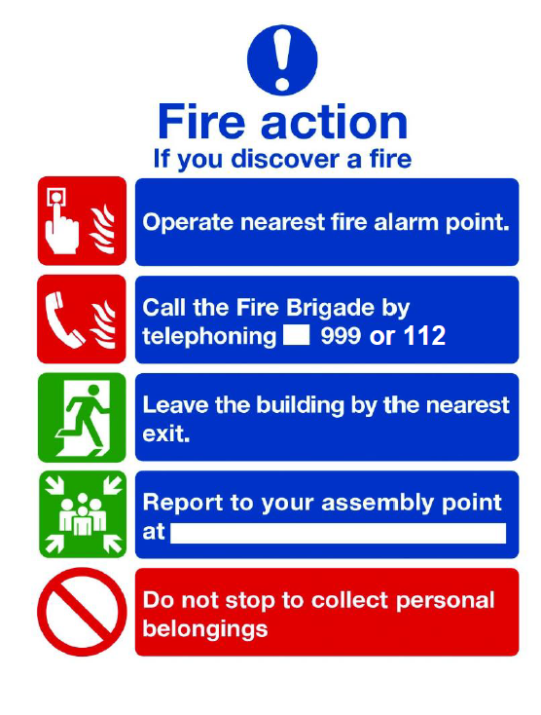

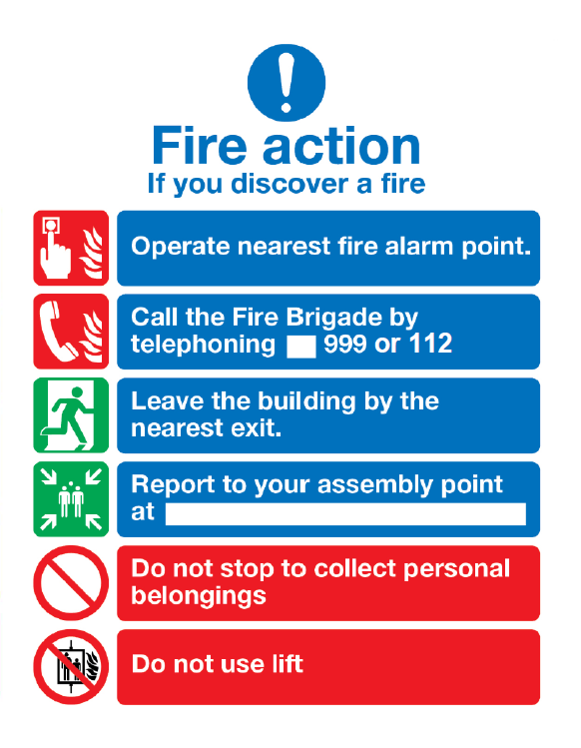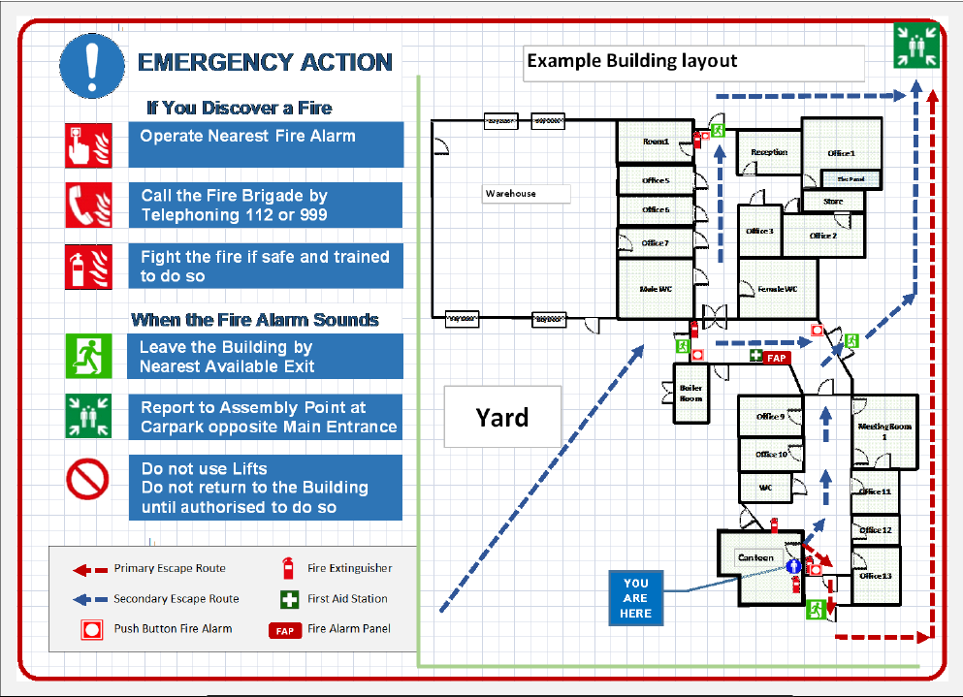

Inventory of fire safety equipment

Fire detection and alarm system
The premises fire detection and alarm system should be inspected and maintained in accordance with IS 3218
Location of Main Fire Alarm Panel
____________________________________________________________________________________________________________________________________________________________________
Location of any Fire Alarm Repeater Panels
______________________________________________________________________________________________________________________________________________________________________________________________________________________________________________________________________________________________________________________________________________________________________________________________________________________________________________________________________________________________________________________________________________________________________________________________

No. of zones ________ No. of detectors _______ No. of manual call points ______
Zone No. ________ Area or coverage ________________________________________________ Zone No. ________ Area or coverage ________________________________________________ Zone No. ________ Area or coverage ________________________________________________ Zone No. ________ Area or coverage ________________________________________________ Zone No. ________ Area or coverage ________________________________________________ Zone No. ________ Area or coverage ________________________________________________ Zone No. ________ Area or coverage ________________________________________________ Zone No. ________ Area or coverage ________________________________________________ Zone No. ________ Area or coverage ________________________________________________ Zone No. ________ Area or coverage ________________________________________________ Zone No. ________ Area or coverage ________________________________________________
Note 1: A zonal plan / diagram should be attached installed at the main fire alarm panel.
Note 2: Where an addressable fire detection and alarm system is installed within the premises the above table does not need to be filled out.
Note 3: Contact your nominated fire alarm service engineer for information on the type of system installed in your premises.

Emergency Lighting
The premises emergency lighting system should be inspected and maintained in accordance with IS 3217
No. of emergency lights ________ No. of emergency exit lights _______
Location of equipment
Number | Type | Location

Firefighting equipment
Fire extinguishers should be inspected and maintained in accordance with IS 291

No. of Fire Extinguishers ________
No. of Hose reels ________
No. of Fire blankets ________
No. of fixed suppression systems ________

Location of equipment
Number | Type | Size | Location

Fire resisting doorsets
The following abbreviations are use in the table below:
FR | Fire resistance (Minutes) | IS | Intumescent strip | CSS | Cold smoke seal
SC | Self-closing device | EDRM | Electronic door release mechanism

Door no. | Location | FR | CSS | IS | SC | EDRM | Glazing

Fire Hydrants
Inspections and maintenance of hydrants should be in accordance with the NDFEM Fire Safety Guide for Building Owners and Operators

No. of Fire Hydrants on the site ________

Number | Size / Type | Location

Hydrant maintenance contractor name and contact details
__________________________________________________________________________________________________________________________________________________________________________________________________________________________________________________________________________________________________________________________________________________________________________________________________________________________

Dry / Wet Risers
Dry / Wet risers should be inspected and maintained in accordance with the NDFEM Fire Safety Guide for Building Owners and Operators. Inspection and testing should be carried out every 6 months. Evidence of the inspections should be detailed in Section 8.

No. of Dry / Wet Risers ________

Number | Size / Type | Location

Fire Safety Checks
This check section in the Fire Safety Register Logbook is applicable to small to medium sized premises. Larger premises may have more specialised systems which may require further management checks and these should be agreed with your technical adviser.

Written procedures on what to do in the event of a fire (See Section 5 above) shall be displayed on the premises and shall be kept as part of the Fire Safety Register Logbook.

Daily checks that should be carried out:
- Are all escape routes clear?
- Is the fire alarm system active and (for panel alarms) not showing a fault?

Electrical system shall be certified every 5 years but should receive a visual check annually.

Gas system (If applicable) should be inspected annually in accordance with IS 820, IS 3216, and Gas Networks Ireland recommendations.

How to use the Checks in this Fire Safety Register Logbook
The end/ beginning of each year cycle should involve obtaining the required annual certificates.
Daily checks should be carried out each day, if there is an issue it should be recorded in the Section 8.5 Log.
Recorded Fire safety checks shall be carried out each week and a monthly check shall be carried out at the end of each month cycle. Monthly checks may be carried out by a member of staff with sufficient training but all quarterly and yearly checks must be carried out by the Fire Safety Manager or the Deputy Fire Safety Manager.
Quarterly checks shall be carried out 4 times each year and should be spread out throughout the year.
At the end of each year there should be a page for each month, a yearly checks page, a quarterly checks page and records of staff training, evacuation drills and completed fire safety equipment logs.

Fire Detection and Alarm Systems
Maintenance of fire alarm systems may vary. For self-contained fire alarm systems a weekly test should be done to ensure the sounders are working on each unit. Annual testing should be carried out in accordance with IS 3218: 2013 + A1: 2019 and certification should be available for inspection.
Staff Training
Staff training should be carried out for each new member of staff and refresher training should be carried out for all staff at least once a year.

Scheduled checks logbook
Section 8 is a Workbook – Multiple copies should be printed to facilitate completion of all checks.

Annual checks

Annual checks |  | Yes | No | N/A | Comment
1. | Quarterly checks carried out and correct?
2. | Fire detection and alarm system certified by a competent person?
3. | Emergency lighting system certified by a competent person?
4. | Fire drills carried out?
5. | All on site fire hydrants inspected?
6. | Electrical system certification in date?
7. | Gas system (if any) certification in date?
8. | Review fire safety signage and location of Assembly points
9. | All staff fire safety training complete?
10. | All fire safety equipment in place and operational?
Checks carried out by: Date: _

Note: The above checks should be carried out annually by the Fire Safety Manager

Quarterly checks
Quarter no.__ checks |  | Yes | No | N/A | Comment
1. | Monthly checks carried out and correct?
2. | Fire detection and alarm system checked by a competent person?
3. | Emergency lighting system checked by a competent person?
Checks carried out by: Date: _

Note: The above checks should be carried out quarterly by the Fire Safety Manager

Monthly Checks
Month of _________________ checks |  | Yes | No | N/A | Comment
1. | Weekly checks carried out and correct?
2. | Are all escape routes, internal and external, accessible and clear of obstructions?
3. | Are all doors on escape routes openable immediately and easily?
4. | Do all elements of the fire detection and alarm system cause and effect operate in all zones when tested?
5. | Are all emergency light diodes illuminated?
6. | Are all maintained fire exit signs illuminated?
7. | Are all fire doors in good working order?
8. | Are all fire extinguishers in the correct location, accessible, and charge gauges in the green zone?
Checks carried out by: Date: _

Note: The above checks should be carried out at the end of each month in place of the final weekly check by the Fire Safety Manager

Weekly Checks
Week no. ___ of _________________ (month) |  | Yes | No | N/A | Comment
1. | Are all escape routes, internal and external, accessible and clear of obstructions?
2. | Are all doors on escape routes openable immediately and easily?
3. | Are all emergency light diodes illuminated?
4. | Are all maintained fire exit signs illuminated?
5. | Are all fire doors in good working order?
6. | Are all fire extinguishers in the correct location, accessible, and charge gauges in the green zone?
Checks carried out by: Date: _

Note: The above checks should be carried out at the end of each week in place of the final daily check by the Fire Safety Manager or a designated person with adequate training.

Issue record
Date: | _____________________________________________________________
Issue recorded by: | Name_________________________ Signed________________________
Issue description: | _____________________________________________________________  _____________________________________________________________  _____________________________________________________________  _____________________________________________________________  _____________________________________________________________  _____________________________________________________________
Issue closed date: | _____________________________________________________________
Issue closed by: | Name_________________________ Signed________________________
Additional Comment: | _____________________________________________________________  _____________________________________________________________  _____________________________________________________________  _____________________________________________________________  _____________________________________________________________  _____________________________________________________________

Note: Issues identified during annual, quarterly, monthly, weekly, and daily checks should be recorded by the Fire Safety Manager or a designated person with adequate training.

Scheduled checks guidance

Escape routes
Ensure that all escape routes and exit doors are maintained free from obstruction and immediately available for use while the premises are in use.
The Minister for the Environment made regulations entitled `Fire Safety in Places of Assembly (Ease of Escape), Regulations 1985, (S.I. No. 249 of 1985)' which place a specific duty on persons in control of premises to ensure that escape routes are kept clear and that doors, gates etc. on these routes and exits can be easily opened by persons using the premises.
Refer to Section 6 the ‘Code of practice for the management of fire safety in places of assembly’ for guidance.

Firefighting Equipment
All extinguishers should be visually inspected to ensure that they:
- are in their proper positions with adequate signage and have a correct mounting, wall / stand;
- have not been discharged;
- have not had their seals or tabs broken;
- have not lost pressure (indicator gauge);
- have the maintenance label properly attached;
- have not suffered obvious damage.
Note: The annual inspection of the firefighting equipment must be carried out by a competent service organisation and the certificate of test submitted in accordance with the recommendations of IS 291.

Fire Alarm System
An inspection should be documented every month as follows:
- A visual examination of the panel to see that are no faults/ muted alarms indicated.
- A visual examination of the battery and connections should be made to ensure that they are in good condition.
- Any defect should be recorded in the Fire Safety Register Logbook and reported to the responsible person, and action should be taken to correct it.
Once a week at least one trigger device on a zone circuit should be operated to test the ability of the control and indicating equipment to receive a signal and to sound the alarm.
Note: An annual and quarterly inspection of the fire alarm system must be carried out by a competent service organisation and the certificate of test submitted in accordance with the recommendations of IS 3218.

Emergency Lighting
A visual inspection should be made once every month to ascertain that:
- A fault recorded in the Fire Safety Register Logbook has been given attention and action noted;
- Every lamp in a maintained system is lighting i.e. exit lights;
- LED (Green or Red) in each luminaire on the charging circuit is illuminated;
- Any fault found is recorded in the Fire Safety Register Logbook and the action taken noted.
Note: An annual and quarterly inspection of the emergency lighting system must be carried out by a competent service organisation and the certificate of test submitted in accordance with the recommendations of IS 3217.

Fire Resisting Doors
An inspection should be made weekly to ascertain that:
- A fault recorded in the Fire Safety Register has been dealt with and the action noted;
- Every fire door closes properly and receiver engages; (self closer working correctly)
- There are gaps no larger than 3 mm between the frame and doors or between meeting door leaves;
- The combined intumescent strip/cold smoke seal is fully intact on the top, sides and at meeting door leaves.
- Magnetic hold open devices are operational and fully close the door to the frame without any gaps. These should be tested weekly when then fire alarm is operated to ensure they release.
- The correct signage is on all doors and both sides;
  - “Fire Door Keep Shut”
  - “Fire Door Keep Locked”
  - “Automatic Fire Door Keep Clear”

Gas Installations
All gas installations shall be tested by a competent person in accordance with the guidance is set out in Annex E of IS 820.
Gas appliances and installations shall be inspected and serviced annually.

Electrical Installations
All existing installations shall be tested by a competent person in an appropriate manner at an interval determined by risk assessment having regard to the nature, location and use of the installation (but not greater than five years) and a report, conforming to IS 10101, of the test be completed by the competent person carrying out the test. Any works required to make the installation safe for use detailed in this report shall be carried out and a new report be completed by a competent person.

