MASS INTENTIONS

(Saturday 30th March to Sunday 7th April 2024)

MYNA CHURCH

SUN 11.30am Jim and Maureen Gibbons and deceased family

members, Cushalogurt.

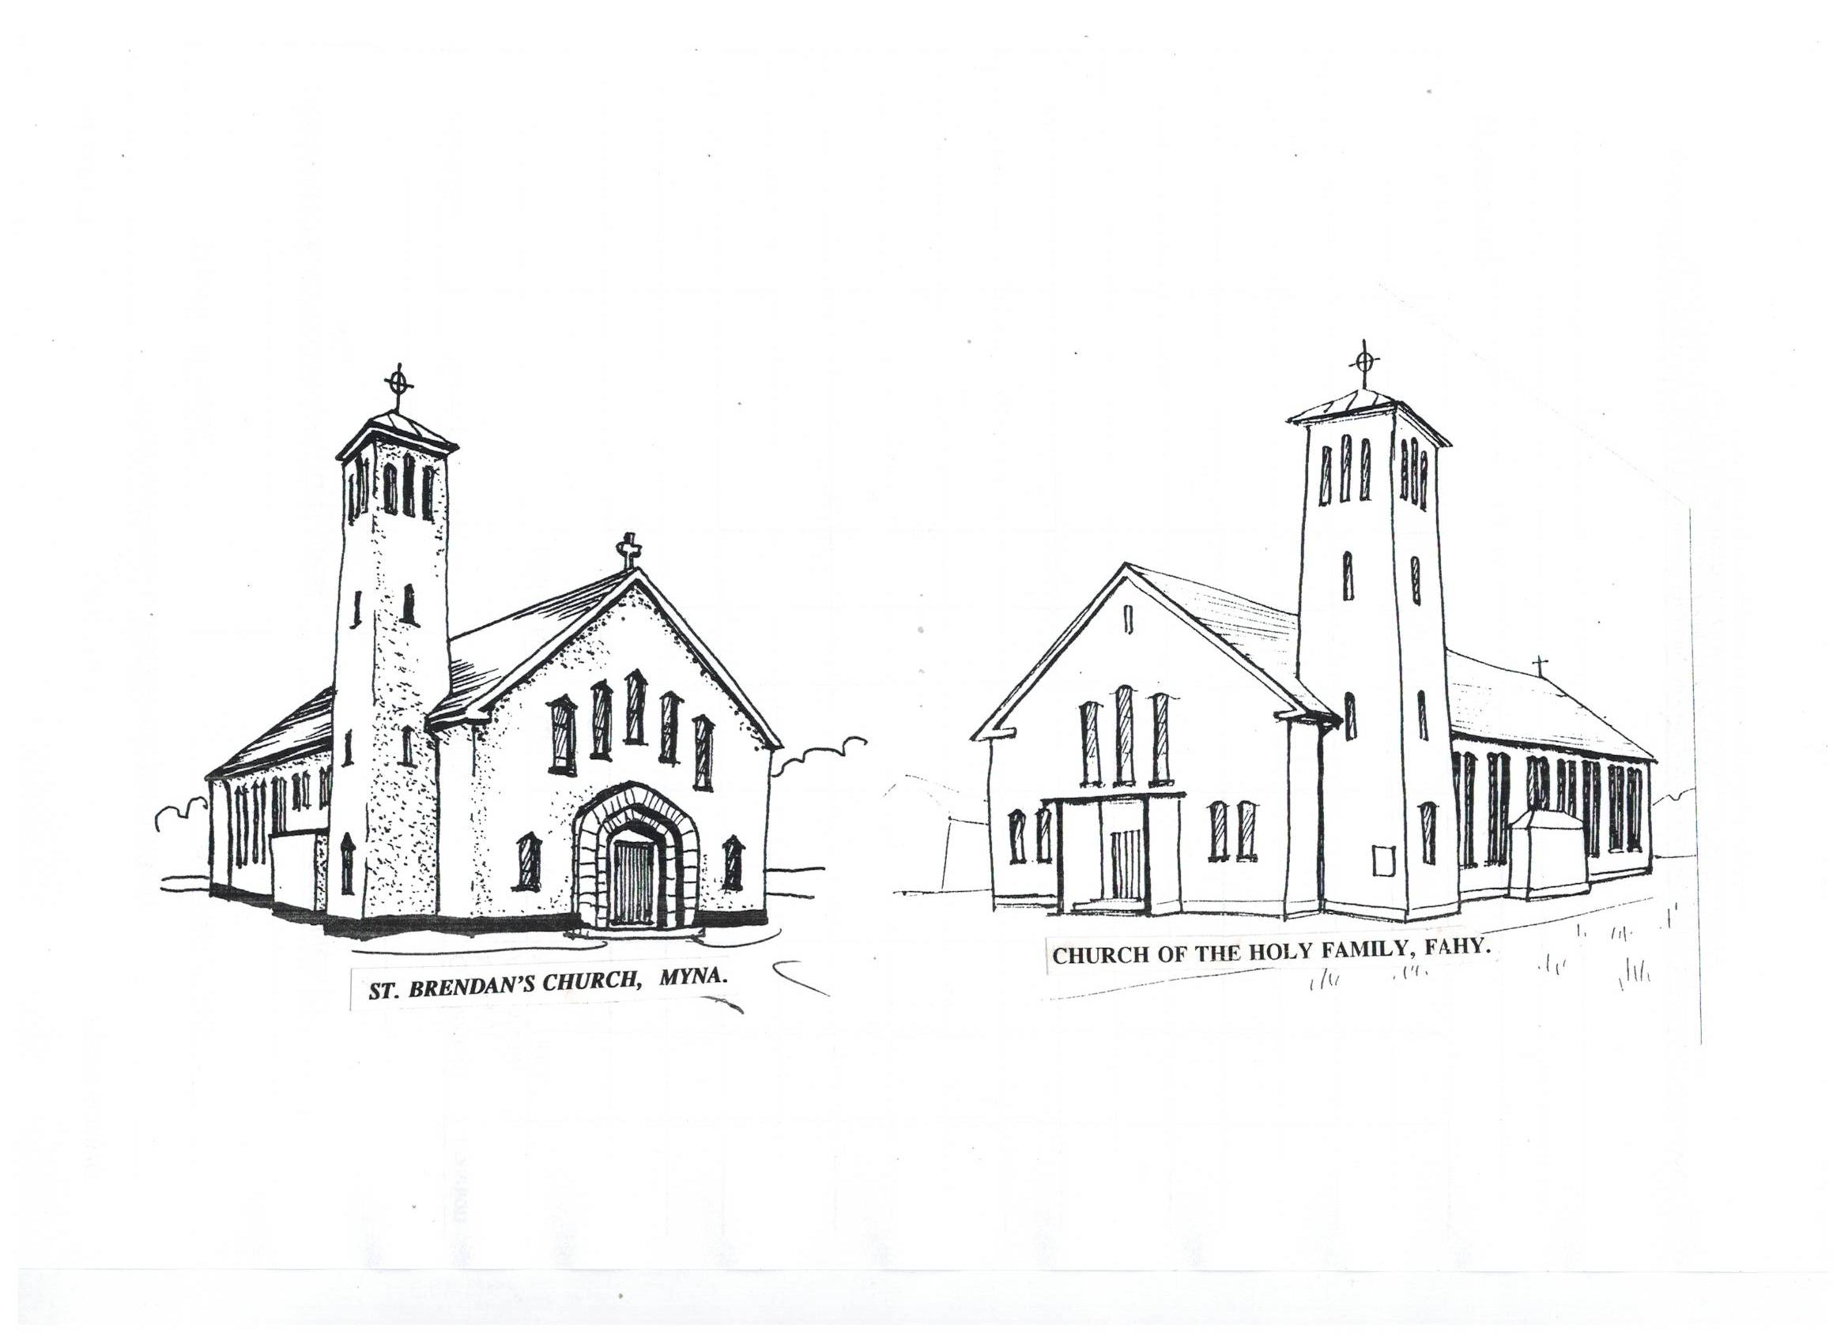
Paddy Golden, Carrowholly and deceased members of

Golden and Gavin families.

WED 9.30am Mass.

FRI 8.00pm Mass.

SUN 11.30am Willie and Bridget Moore, Clynish and deceased family

members.

Sean and Susan O’Kelly, Roscahill and daughter Pauline

and daughter-in-law Pauline and deceased family members.

Jack and Josephine Duffy and daughter Mary and

deceased family members.

Hannah Keane (A), Ardkeen.

Agnes Cox, Mayour and daughter Maire Bourke and

deceased family members.

FAHY CHURCH

SAT 7.00pm . Easter Vigil Mass.

TUE 8.00pm Mass

THU. 9.30am Patrick and Catherine Moore, Drimgar and deceased

family members.

SAT 7.00pm . Josie and Mary Durkan, Aughagowla and parents Pat

and Nora and Padraig and Alice and deceased family members.

Annie and John Keane and deceased family members, Cortoon.

*****
MINISTERS OF THE WORD:

Myna Church: -
Sun 31st ^{h} March – Eoghan Smyth. Sun 7th April – Margaret Staunton

Fahy Church: -
Sat 30th March– Catherine Lawless. Sat 6th April – Carmel Keane.

APRIL 2024 CHURCH OFFERTORY COLLECTORS:

Myna - Derek Walshe and Tom Feehan
Fahy - Monica Gannon
KILMEENA – FAHY PARISH

NEWSLETTER

Sunday 31st March 2024

Easter Sunday

This Easter Sunday – resurrection Sunday – a day of new hopes, new beginnings. It is a day of great rejoicing – a birthday for all peoples.

Fr. Jim Walsh, P.P. (098-41270)

PARISH NEWS:

EASTER GREETINGS:
Fr. Jim sends Easter Greetings to all parishioners and to all who are on holidays in the parish. May it be a very happy and blessed time for all of you and your families. Fr. Jim and the Pastoral Council wishes to thank all who helped with the Holy Week ceremonies. We thank especially the Ministers of the Word, Ministers of the Eucharist, the Choirs, the Offertory Collectors, the Mass Servers, those who prepared the Altars, those who set up the Holy Week symbols and presentations, those who cleaned the churches and all who helped in any way.
MAY THE RISEN CHRIST BLESS AND REWARD YOU ALL.

*****
DIVINE MERCY SUNDAY:

Next Sunday, 7th April, is Divine Mercy Sunday. This feast was instituted by Pope John Paul II following revelations to Sr. Faustina of Poland. This feast emphasises the infinite mercy of God to all who repent of their sins.

*****.
FEASTS OF THE WEEK:

Monday St Ceallach was born in 1080, became Abbot of Armagh

and priest in 1105 and presided at the Synod of Rathbreaail

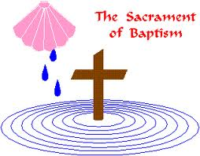
in 1111.

Wednesday: St. Isidore, bishop and doctor of the church. He became bishop of Seville in 600 and died there in 636. His writings were like an encyclopaedia of knowledge.

Thursday: St. Vincent Ferrer (1350-1419). He was a Dominican priest and preached missions in his native Spain but also in France and Italy.

****
TRÓCAIRE COLLECTION BOXES

Please return your Trócaire Collection to the church next Sunday or as soon as possible. We would be grateful if you could change small coins into notes or large coins.

****
TOCHAR WALK:
The next Tochar Phadraig Walk will take place on Easter Monday, 1st April. This is a guided 15km walk of the Thochar Phádraig pilgrim path between Ballintubber Abbey and Aughagower. To registrar contact 094- 9030934 or e-mail info@ballintubbetabbey.ie.

BLESSING OF THE ROADS:

This blessing of roads will take place in Fahy after the Easter Vigil Mass and in Myna after Mass on Easter Sunday. The community needs to make road safety a personal goal or we will continue to have families suffer the grief associated with loss of life and serious injury.

The Motorist Prayer
Lord, grant me a steady hand and a watchful eye
That no person may be hurt when I pass by.
Thou gavest life. I pray no act of mine
May take away or mar that act of Thine. Amen

EASTER COLLECTION:

The Priests’ Easter Collection is one of four collections during the year. The collection at Christmas, Easter, Summer and Autumn are the only collections used to support the priests. Thanks for your generous support. Please use the special envelope in the box of envelopes or any envelope marked “Priests Collection.” You can leave your offering in the Letter box at the Parochial House. Should you wish to pay on-line, the Priests’ Revenue account - (iban IE95AIBK93716917205014). Please remember to include your name and envelope number.

****
BAPTISM:
We welcome into God’s family and our parish community Conor William Duggan son of Joanna (Potter) and Ian, Derryribbeen.

*****

The West Mayo Old IRA Brigade Annual Mass will be held in St Patrick's Church, Newport,, Co Mayo on Easter Monday 1st April at 12 noon. Refreshments will be available afterwards in Brannens, Newport.


RECENT DEATH:

Please remember in your prayers: -
Bernadette Fahy (nee O’Malley, Claggan), Ballyheane, Castlebar.

MAY SHE REST IN PEACE

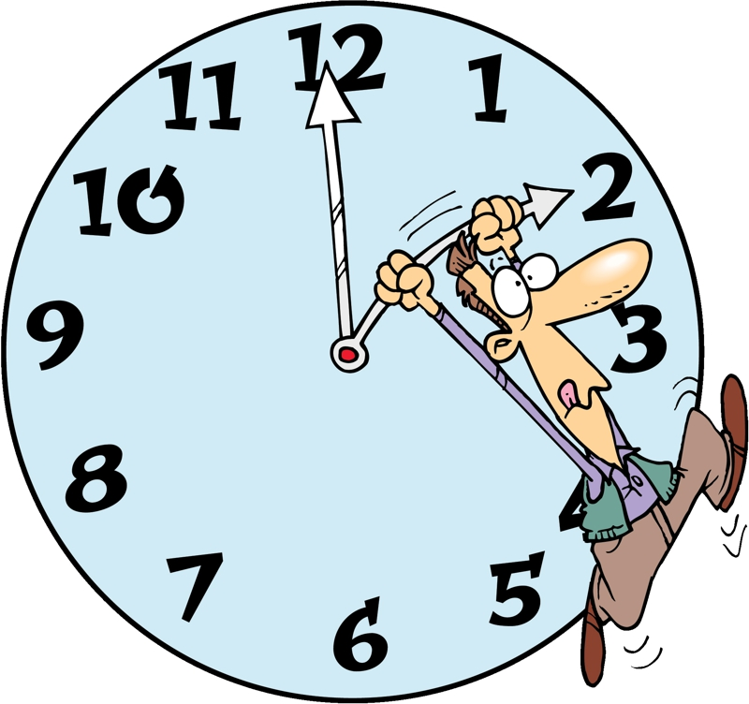
SUMMERTIME: Summer Time begins this Saturday night. Don’t forget to put your clock forward one hour before going to bed on Saturday night..

